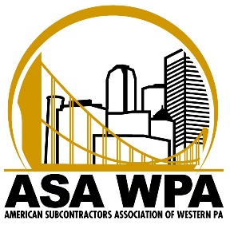

ASA Young Subcontractors – Pub Crawl -Southside - Thursday, October 10th

6:00 PM 6:50pm
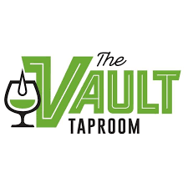

7:30pm

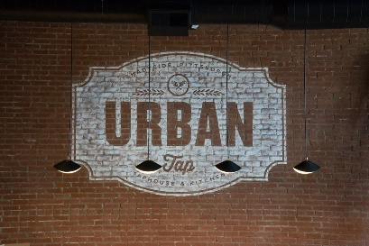

Price of Admission: $30.00 Price includes
- Appetizers @ The Flats
- $10.00 drink card at The Vault

Online Registration Only: https://www.subcontractorswesternpa.com/blog/events/pub-crawl-southside-hosted-by-asa-young-subcontractors/

All proceeds will go to support ASA’s Scholarship Fund
All Members and guests are welcome to attend. The Young Subcontractors are hosting this event.

ASA Western PA, 565 Callery Road, Cranberry Twp, PA 16066
724.538.8227 Phone & Fax E-mail: Angie@asawpa.org

