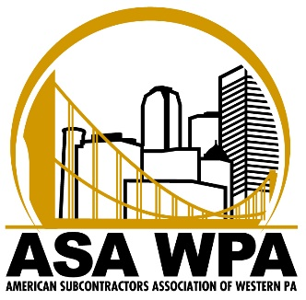

ASA WPA STUDENT SCHOLARSHIP APPLICATION
FOR THE YEAR 2020/21

NAME

DATE

HOME ADDRESS

HIGH SCHOOL CITY, STATE GRAD. DATE

TECHNICAL SCHOOL CITY, STATE EXPECTED GRAD. DATE

TRADE / TECHNICAL FOCUS (please select all applicable)
- Carpentry
- HVAC (sheet metal, steamfitter)
- Plumbing
- Masonry
- Industrial
- Estimating
- Welding
- Computer Modeling
- Administrative
- Electrical
- Other _______________
Application must be postmarked or delivered to ASA WPA by October 31, 2019 for consideration

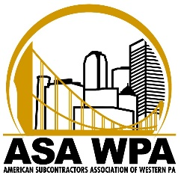

- If applicable, list any extra-curricular activities that you participated in (community service, church youth groups, volunteer work, etc.), including length of service, awards, honors or scholarships you have received. Include dates of awards. (Attach extra sheet if necessary)

- If applicable, list previous summer/part time jobs, internships/co-ops, military service, etc. (Attach extra sheet if necessary)

- Describe in detail an accomplishment(s) that you have achieved while you were a student. Why were you successful? How will your success influence your future plans in the construction trades?

- Describe in detail your strengths and interests. Describe how you will apply your skills to a career in the construction field.

- Describe in detail a challenge that the construction industry will need to face in the future. What opportunities exist for technical graduates to help companies deal with that challenge?

- Where do you see yourself in the future? 5 Years from now? 10 Years from now?

- Tell us something about yourself that you would like the Evaluation Committee to know?

- Why are you interested in the trade you selected?

- Scholastic Performance:

Please attach a copy of your most recent transcript, including grade point average and class rank. Also, include a copy of test result scores from the ACT or SAT exam, if applicable*

* Taking ACT or SAT is not a mandatory requirement.

The American Subcontractors Association of Western PA is committed to building relationships within the construction industry to create a favorable community between subcontractors and general contractors. We achieve this through networking, advocacy and social activities within the construction community.

Application must be postmarked or delivered to ASA WPA by October 31, 2019 for consideration
Mailing address: ASA Western PA 565 Callery Road Cranberry Twp., PA 16066

