ASA 2018 Golf Outing Monday

August 20, 2018

OPEN BAR 4:00PM – 5:00PM

Chartiers Country Club



Club Attire

**Club Attire :** Males – collared shirts tucked in and slacks or Bermuda type shorts. Shirts may be untucked if Camp-Style or designed to be worn untucked. Shirts with tails must be tucked in at all times. Clothing must be suitable for Club environment. Comparable attire required for females.

Event Sponsor

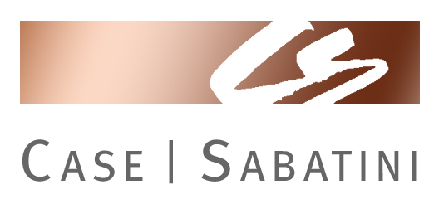

**RSVP**  by Monday, August 10th

**Online Registration: www.asawpa.org**

**Contact** Angela Wentz, Executive Director, 565 Callery Road, Cranberry Twp. 16066, Phone & Fax: (724)538-8227

E-mail: [asawpa@zoominternet.net](mailto:asawpa@zoominternet.net)

**Pricing for Golfers**

Reservations must be received by August 10th

* $260 / Single Golfer
* $520 / Twosome
* $985 / Foursome
* $1,075 / Foursome + Hole Sponsorship
* $85 / Dinner Only

jj

**Registration** 8:30-9:45am **Breakfast** 8:30 – 9:45am

**Shot Gun Start** 10:00am **Dinner and Prizes:** 5:00pm

**Reservations online**

**Golfers Name(s) Company Phone E-mail**

**Total Golfers Fee: $ _______ Dinner Sponsor $500 $ _________**

**Hole Sponsorship $125 $ _______ Beverage Sponsor $300 $ _________**

**Bar Sponsor $300 $ _______ Photo Sponsor $200 $ _________**

**Breakfast Sponsor $250 $ ________ Cash Donations $ _________**

**Dinner Only $85 $ ________ Total Amount Enclosed $ _________**