Event Sponsor
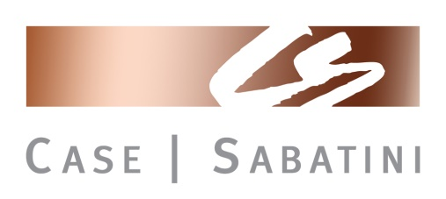
Bar Sponsor - $300
Lunch Sponsors - $250
Dinner Sponsors - $500
1 Beverage Sponsor - $300
1 Photographer Sponsor - $200

My company will be the Event Sponsor $1,500

_______________________SOLD_________________

My company will be a Bar Sponsor #300

_________________________________________________

My company will be Lunch Sponsor $250

_________________________________________________

My company will be Dinner Sponsor $500

_________________________________________________

My company will be The Beverage Sponsor $300

_________________________________________________

Sponsorship Opportunities
2018 Golf Outing
Monday, August 20th
Chartiers Country Club
9:00am – 6:00pm

Hole Sponsor Sign - $125
2 Hole Sponsor Signs - $200
Companies with two signs will have one on the front nine and one on the back nine
Poster at Registration Table will display all Holes Sponsors

My company will be The Photographer Sponsor $200

______________________________________________

My company will be a Hole Sponsor $125

_______________________________________________

My company will take 2 Hole Sponsor Signs $200

_______________________________________________

E-mail: asawpa@zoominternet.net
Website: www.asawpa.org

Register online: www.asawpa.org

American Subcontractors Association of Western PA
565 Callery Road, Cranberry Township, PA 16066
Phone: (7 24) 538-8227 Fax: (724) 724-538-8227

ASA Western PA Sponsorship Details
- Event Sponsor
- Includes 1 foursome
- Event Poster displayed at Registration, Cocktail Hour & Dinner
- Recognition during Awards
- Company logo on all flyers

- Bar Sponsors
  - Sponsor Sign on Patio during cocktail and dinner hour
  - Bar Sponsor Poster at Registration Table

- Lunch Sponsors
  - Names of sponsors on each table, 8-1/2 x 11
  - Sponsor Poster at Registration Table

- Dinner Sponsors
  - Names of sponsors at each table, 8-1/2 x 11
  - Sponsor Poster at Registration Table and on Vernada
  - PowerPoint during dinner recognizing Dinner Sponsors

- Beverage Sponsor
  - Company logo listed on the front of the beverage cart
  - Sponsor Poster at Registration Table

- Photographer Sponsor
  - Company may provide a shirt and hat with your logo on it for the photographer to wear the entire day
  - Sponsor Poster at Registration Table

- Hole Sponsor
  - Tee sign will be placed on the course
  - Hole Sponsor Poster at Registration Table and Veranda

- Hole Sponsor - 2
  - Tee signs; one on the front nine, one on the back nine
  - Hole Sponsor Poster at Registration Table and Veranda

